Adding Screencasts to your CALI Author Lesson (Using Camtasia)
As you work in CALI Author developing your lesson, you may want to add a screencast video to demonstrate an activity that is described in your lesson content. For example, in the Georgia Secondary Sources CALI lesson, the authors wanted to show how to do a search for the keywords “wrongful death” in the treatise Georgia Law of Torts using an online legal research database.
There are a variety of software products that you can use to create screencasts, such as Captivate or Camtasia. For the purposes of this tutorial, you will see how to build a screencast in Camtasia.
Before we get started, it’s important to go over some terms. AVI is a video format. Movies that are in AVI format can play back in media players on your computer (such as Windows Media Player). FLV and SWF are Flash movie formats, which can be viewed in a Flash Player…and with CALI Author, you can use any of these video types, AVI, FLV or SWF.
There are five steps in the process for creating a screencast video:
- Storyboarding
- Capturing the screens
- Recording the audio
- Publishing to AVI or SWF
- Adding the movie to your CALI Lesson
Step 1: Storyboarding
This is the most important step. Making a “blueprint” of what you would like to capture in advance will save you a great deal of time when you are ready to build out your screencast. It’s a good practice to keep your screencasts smaller in duration and capture only what you need to effectively demonstrate the task you are teaching to your learners. By storyboarding in advance, you can visualize what your screencast will look like and pare it down before you begin capturing. A storyboard document can be done in any word processing software. Below is an example of a storyboard created in table format.
Screen # | On-Screen Image | Action | Audio Narration
1 | Wilson Web advanced search screen | Type in the word “torts” and “georgia”, leave all other default search settings as is and click Start. | Patrick uses the index to legal periodicals online.  In the find box, he enters the search terms torts and Georgia and then he clicks start to begin his search.
2 | Wilson Web search results screen (scrolled down so that the Marlowe article appears in the middle of the page). | Check the box next to the Marlowe article, and click Full Text HTML. | Several pages of citations to useful articles are displayed. Patrick finds an article about the restatement of torts that looks promising.
Once you’ve created your storyboard and have the blueprint in hand, you are ready to capture!
Step 2: Capturing
Navigate to the first Web page that you want to record for your screencast. Launch Camtasia Studio and from the Welcome screen, click on Record the Screen. The Capture Tool bar appears, as shown below.
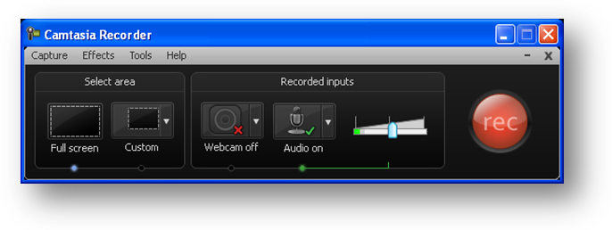
Turn off the audio recording because we will do that later. Do this by clicking the dropdown arrow next to the Audio on button and select Do not record microphone.
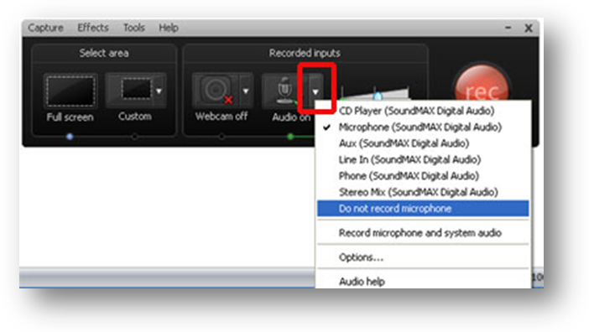
Next, select the area you want to capture (either Full screen or Custom). If you choose Custom, enter in the dimensions if you are recording a smaller area and not the full screen. In this example below, we are using 640X480.
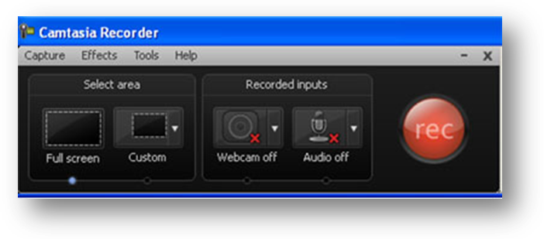
Note that the 640X480 size fits icely in the CALI Author video page and scales well when your students click on the plus sign to enlarge it when watching the lesson. It is a good practice to follow by using the same standards for each video you create for your CALI lesson.
A red 640X480 rectangular recording window will appear on the screen.  You will notice the border and square handles along the edges of the recording window.  Click and drag these handles to move move the position of the recording window. | 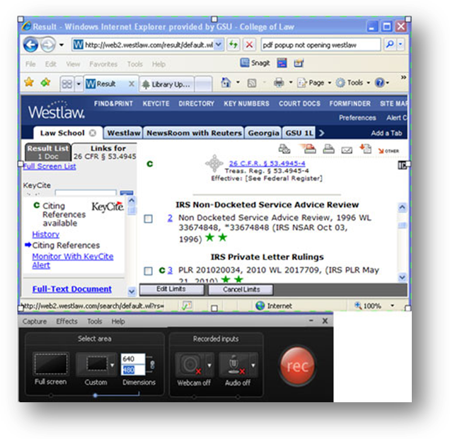
You may need to resize the Web page so that what you want to capture fits in the constraints of the 640X480 window. Keep in mind you don’t have to capture the entire web page, rather the focus should be on the section and actions that you are demonstrating. Camtasia has an automatic feature that will zoom and pan in on the areas you click while capturing, too.

To begin recording, click on the Rec Button in the Capture tool bar.

Go slowly and follow the actions specified in the storyboard. When you are finished, press the F10 key on your keyboard to stop recording.

When you finish recording, Camtasia will then open and display your screencast, as shown below.
Click Save and Edit to begin modifying your video.
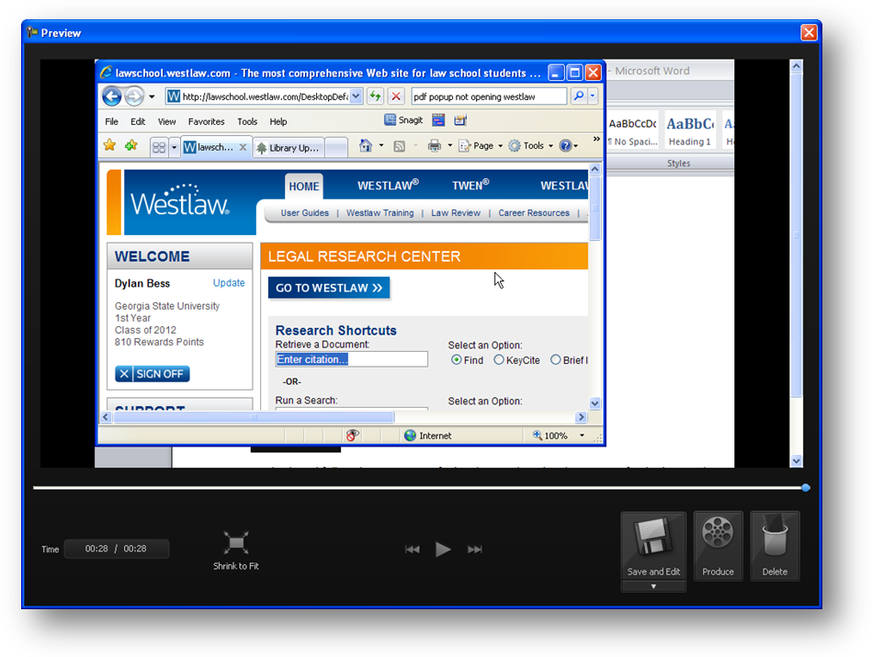

Save the file on your computer. | 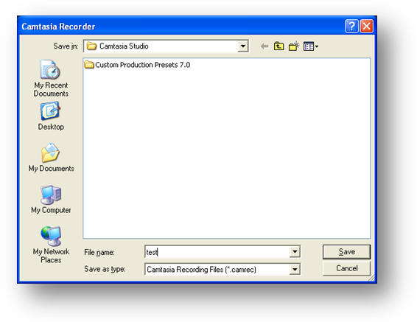

Camtasia will ask you what size you want your video to be.  In this example, we are using 640X480.  Click OK. | 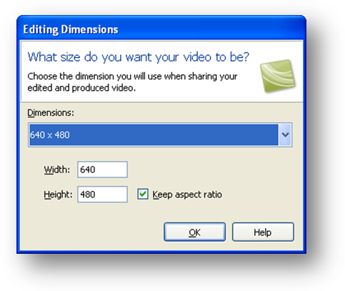

Now that you have captured the images for your screencast, it’s time to record the audio.

Step 3: Record Audio
To record the audio, you have several options. You can hook up a USB or stereo-mini microphone to your computer and record directly into Camtasia, or you can record the audio with an MP3 recorder and import the file into Camatasia.
The advantages of recording directly into Camtasia with a microphone is that it is more convenient and requires less time. A disadvantage is that if your office has a noisy HVAC system or a lot of ambient noise, the microphone will pick that up. There are some processing features in Camtasia that will improve the sound quality of the audio, but some background noise may be hard to remove. You may prefer to record with a portable MP3 recorder. That way, you can find a quiet spot and read your storyboard script without having to be in front of the computer.
Recording directly into Camtasia
To record directly into Camtasia with a microphone, click the Voice Narration button.
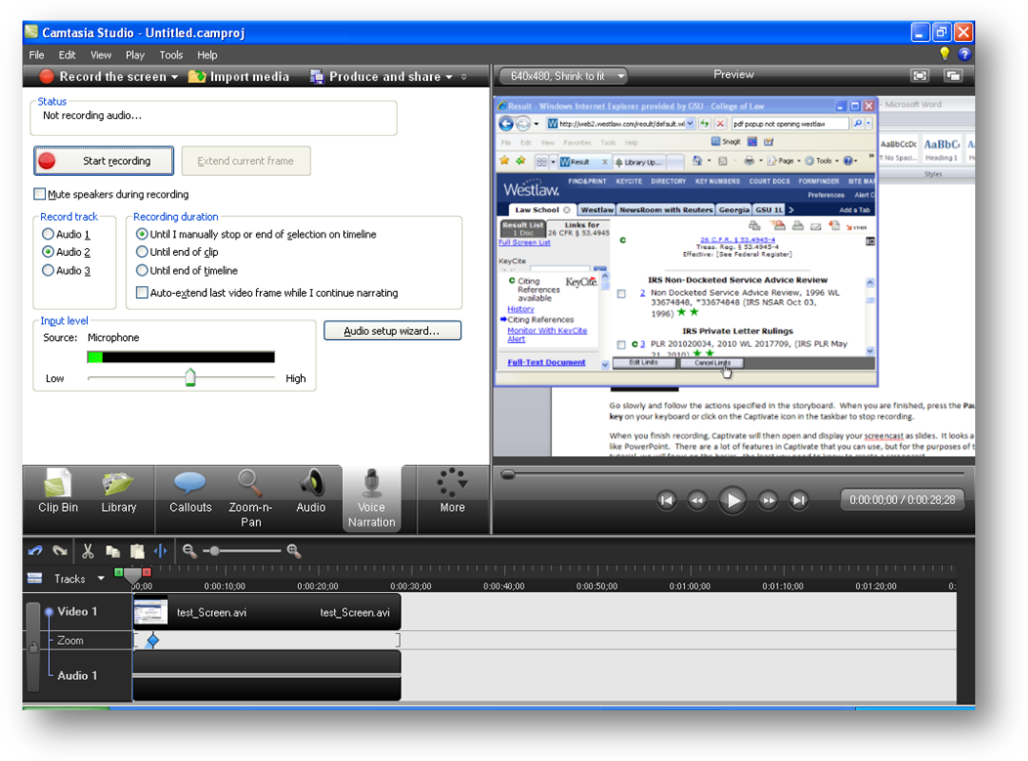

Click the Audio Setup Wizard button and follow the prompts to set your microphone levels. | 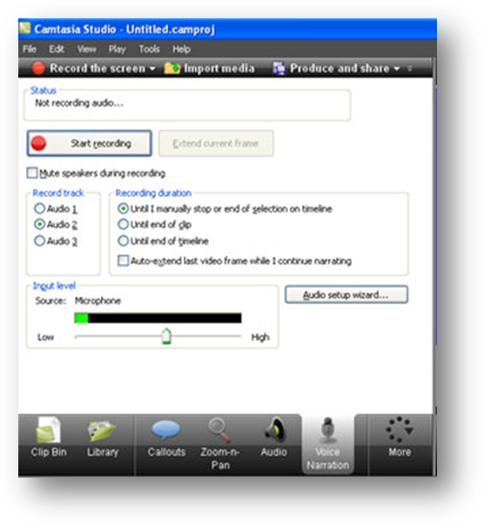

You may want to mute your speakers if you are not using headphones while recording. Click the Mute speakers during recording checkbox.

When you are ready to record, click the Start Recording button.

Your video will play as you record your voice narration for the video.  Click the Stop Recording button when you are finished recording. | 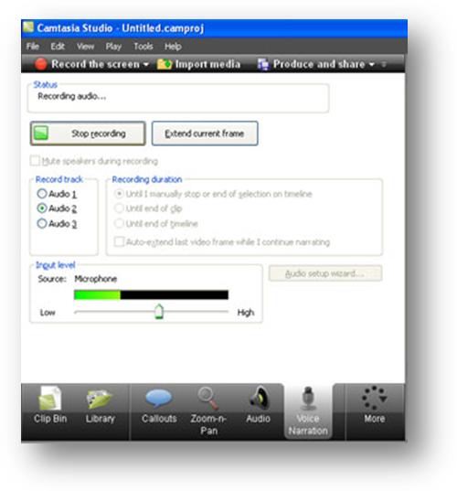
The audio track appears in the timeline window. | 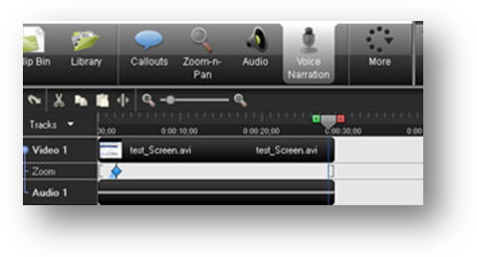
Click the video controls to playback what you recorded and preview your screencast. | 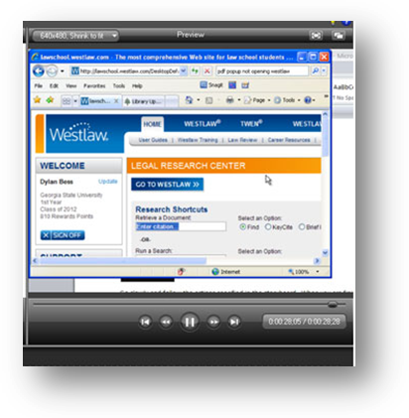
Importing audio into Camtasia
If you record with an MP3 recorder, transfer the MP3 file to your computer.
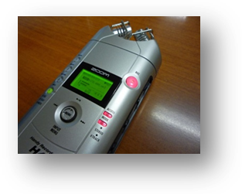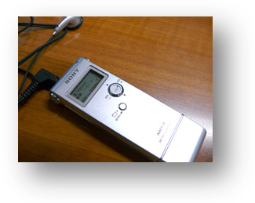
Examples of MP3 recorders
After you’ve transferred the file to your computer, you will want to edit it. There are is variety of audio editing software available, some open source…such as Audacity, which can be found at sourceforge.net. You can also use Camtasia to edit the audio and split the audio file among the slides.
In Camtasia, click Import Media and navigate to your audio file. Click Open, as shown below.
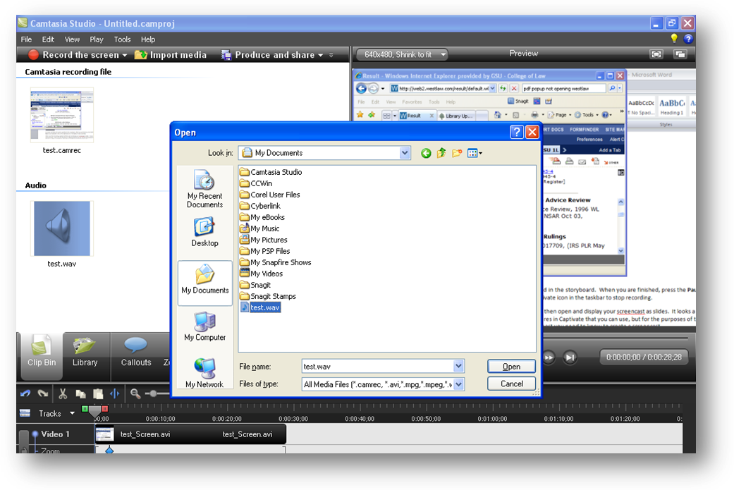

Click on the audio file in the Clip Bin and drag it to the timeline as shown below. Camtasia will automatically add the audio track in.
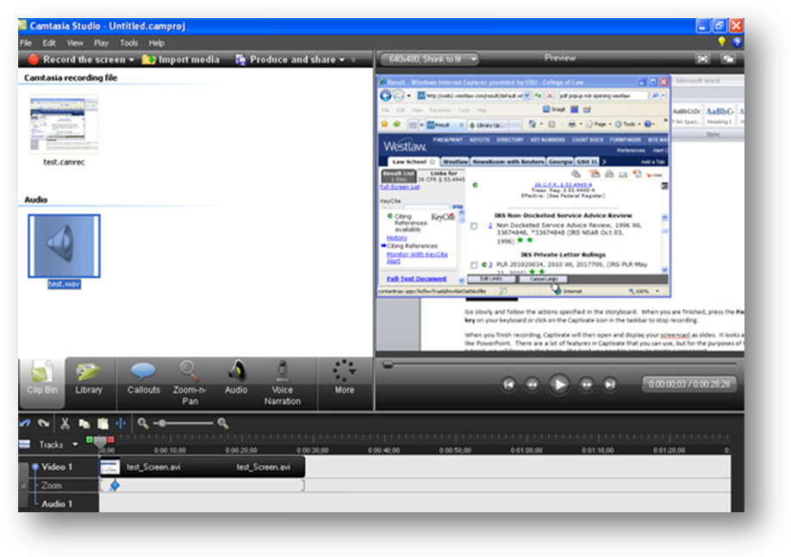
You can move the position of the audio clip by dragging the clip along the timeline. You can also move the ends of the clip to edit the audio clip, if needed. There are more editing features in Camtasia covered in the product’s help documentation, but for the purposes of this guide, we will stick to the least you need to know to make a screencast.

Step 4 - Publishing to AVI, FLV or SWF
Once you have completed building your screencast, you are ready to publish it to a file that you can put in your CALI lesson. In Camtasia, click on the Preview and Share button in the toolbar.
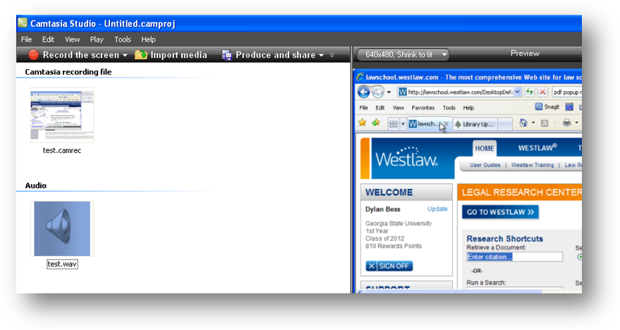
Choose Custom production settings and click Next. | 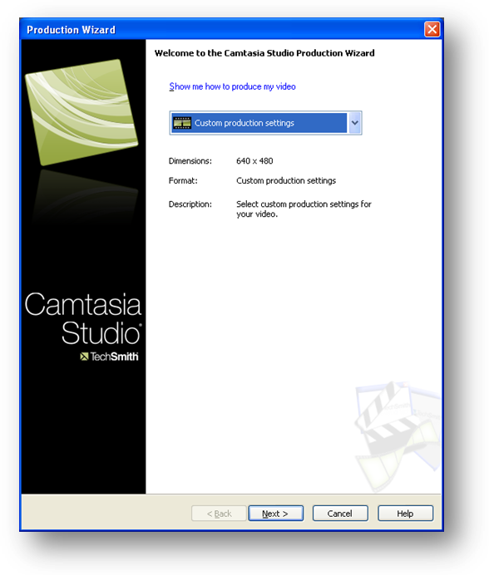

To publish an AVI video file, Select AVI and click Next. | 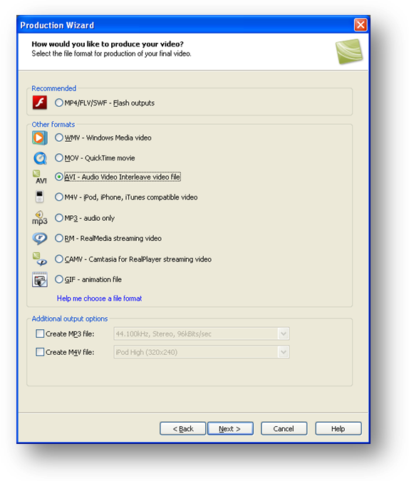
Click Next again. | 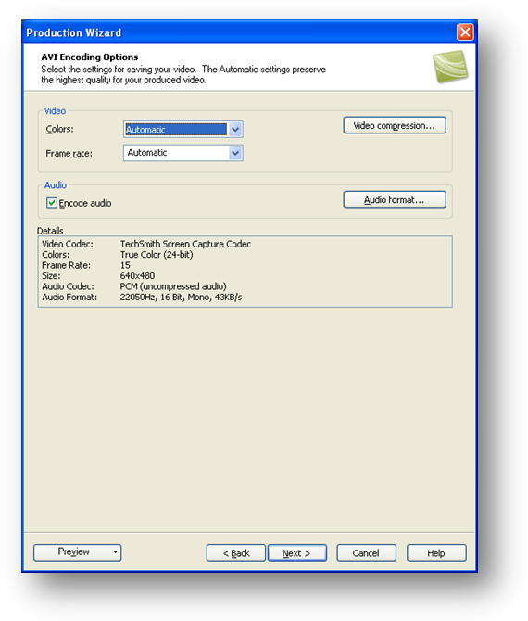

Click Next again. | 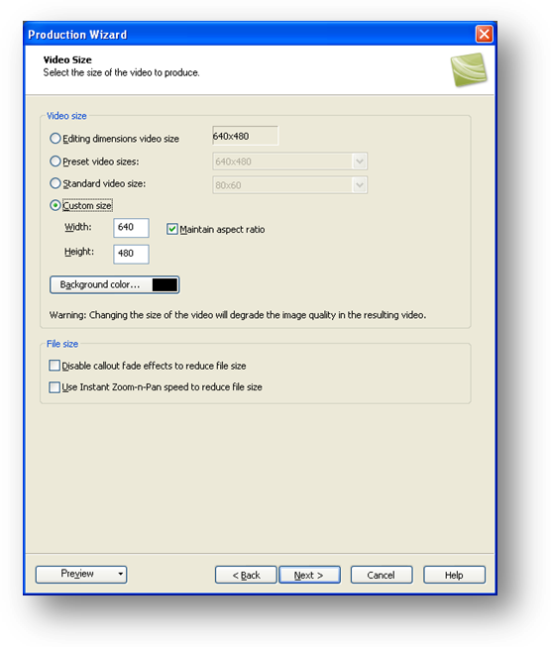
Click Next again. | 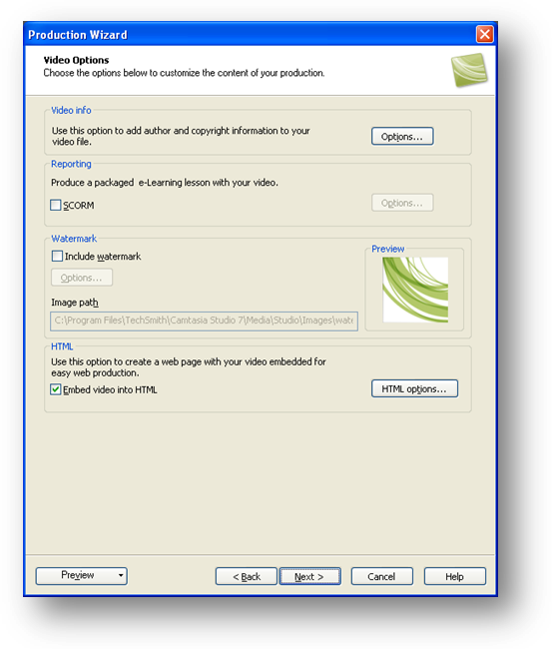

Uncheck the Embed video into HTML checkbox and click Next. | 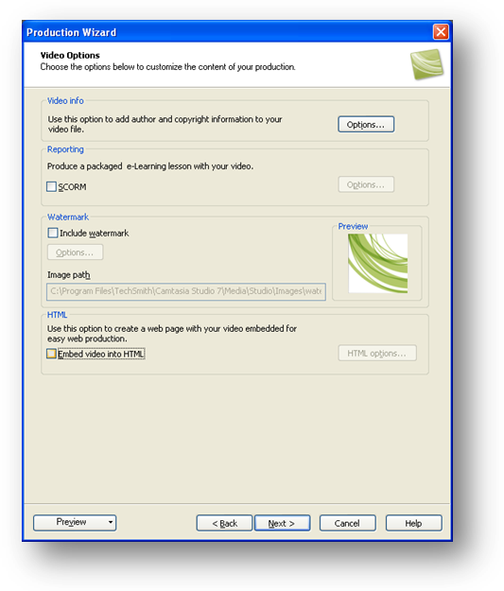
Click Next. | 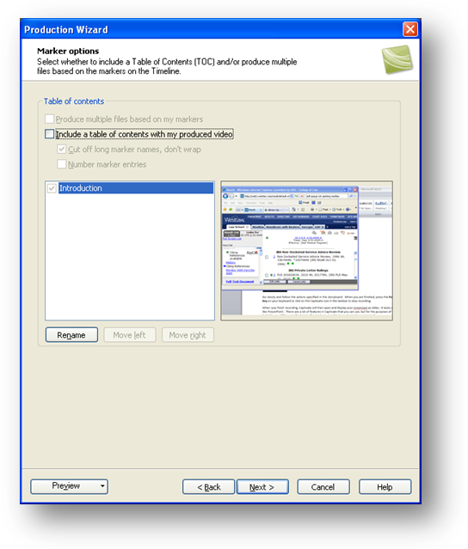

Name your file and select the folder where you want to publish the file.  Click Finish. | 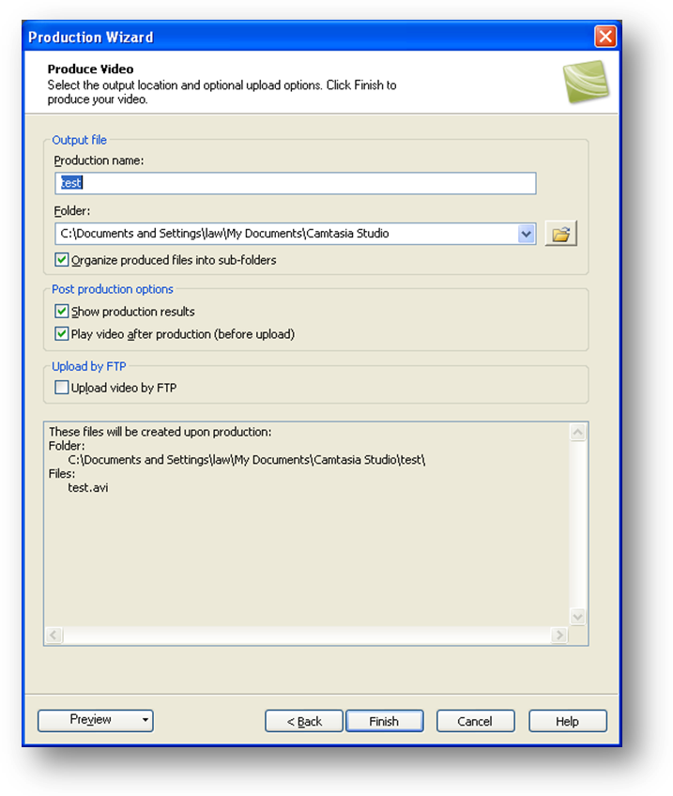

To Publish to FLV or SWF, instead of choosing AVI in the Production Wizard dialog box, choose MP4/FLV/SWF outputs and click Next. | 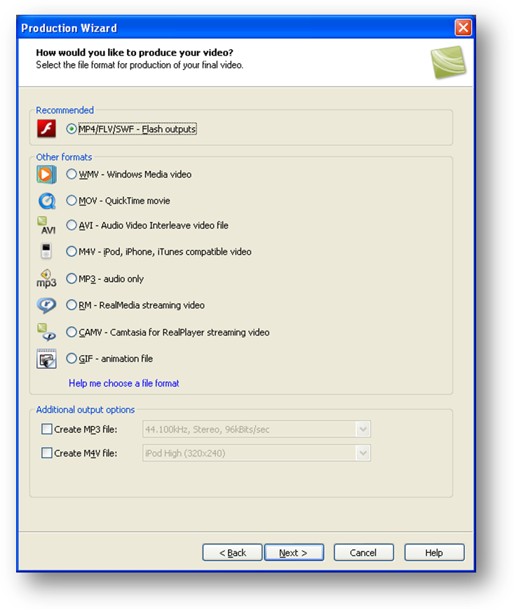

Choose the template No Controls.  Click the Flash options button. | 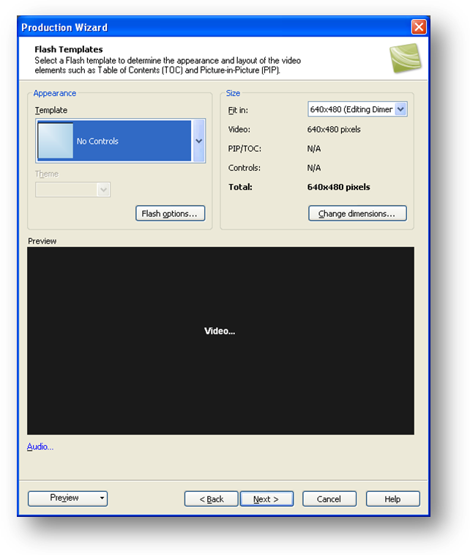
Choose FLV or SWF based on the descriptions provided by each option.  Click Apply and then click OK. | 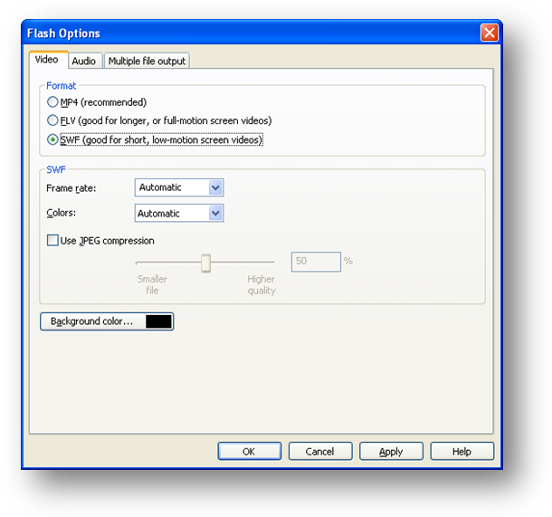
Click Next. |  |  | 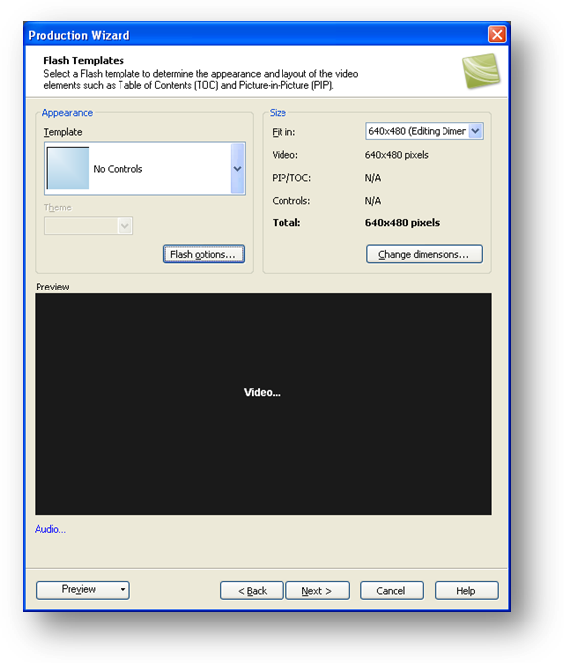
Click Next. |  |  | 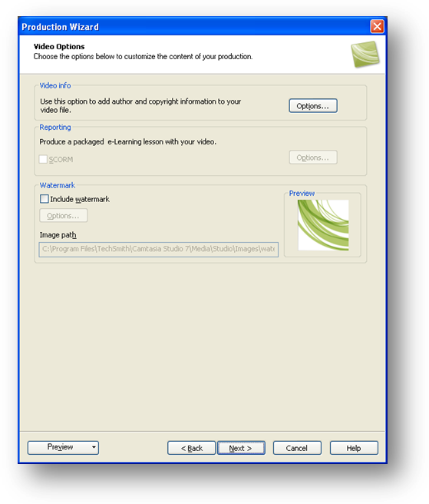
Name your file and select the folder where you want to publish.  Click Finish. |  | 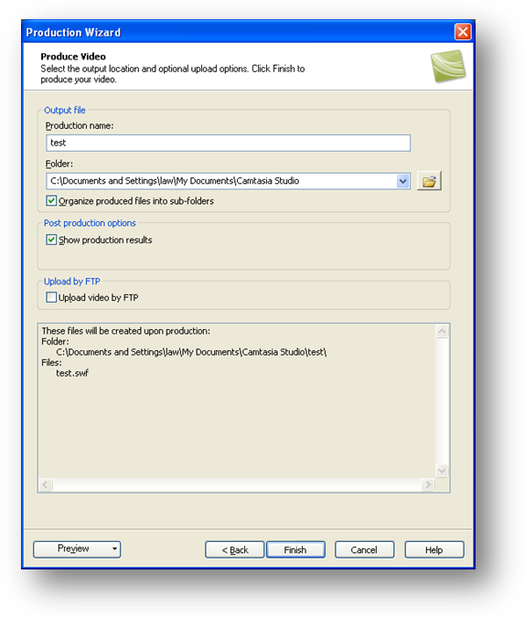
Click Finish again. |  | 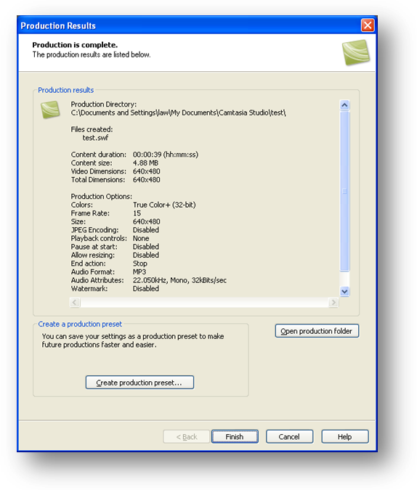
Step 5 - Adding the movie to your CALI Lesson
To add a screencast to your CALI Lesson, be sure to put the video file in the same folder with your CALI Lesson Book. Open your lesson in Authoring Mode, and go to the page where you would like the screencast to play and click the Question tab. Then click the Video tab.
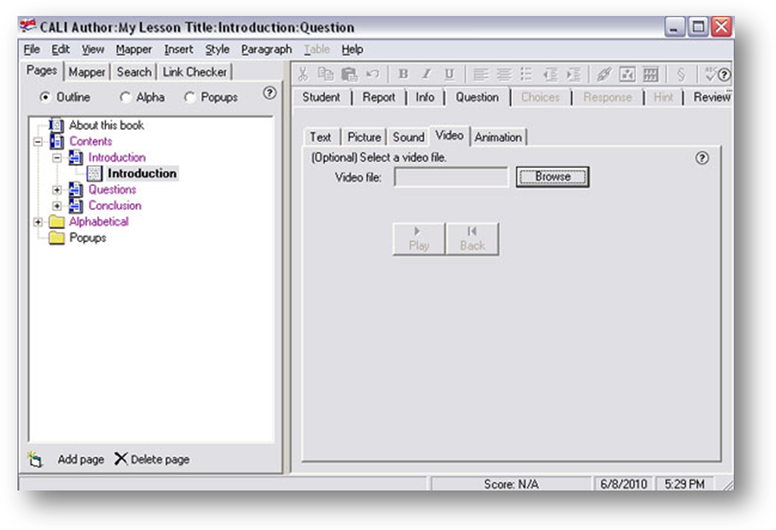
Click the Browse button to navigate to the screencast video file you created and then click on the file type you want to add.  Click Open. | 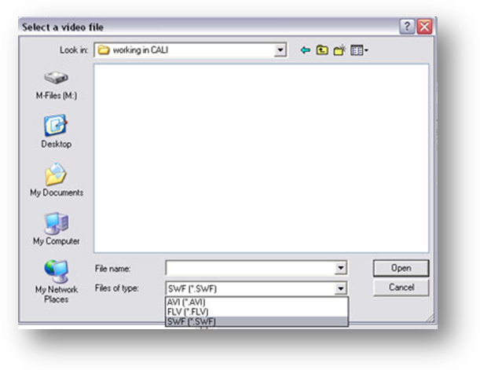

Your video will be added to the page. | 